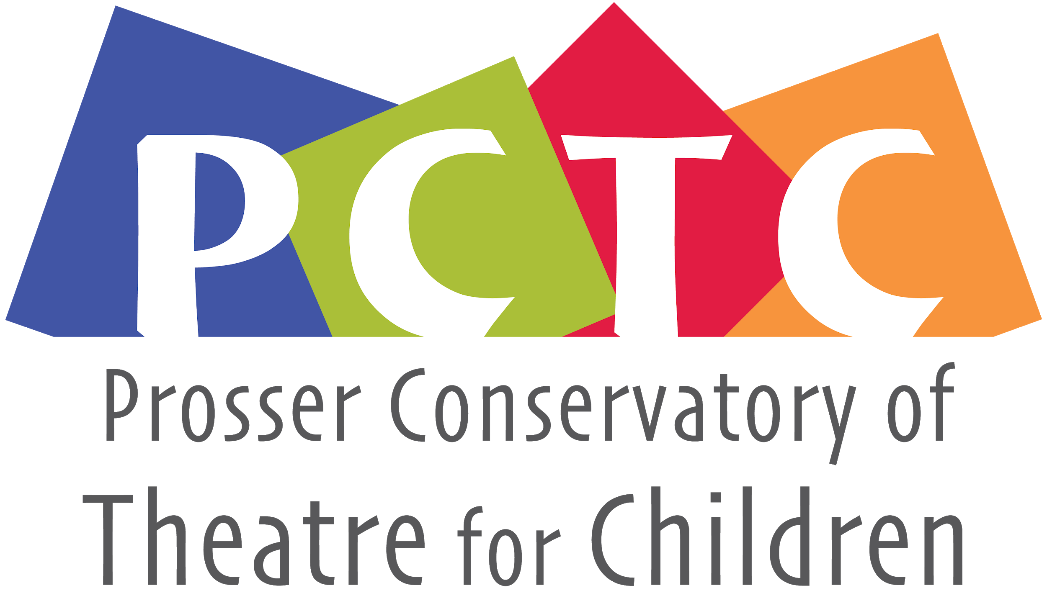
PO Box 1230 , Prosser, WA 99350
prosserconservatory@gmail.com
General Membership Meeting
October 19th, 2021 7:45pm • Virtual Zoom Meeting

Board Members
’20-‘22  Monica Ray  Lesa Park  JP Estey  Bethany Riddle | ’19-‘21  Andie Slonecker  Nathan Harris  Ashleigh Thornock  Eva Petroff  Student rep N/A

Call to order: 7:51
Present: Monica Ray, Andie Slonecker, Nathan Harris, JP Estey, Bethany Riddle, Lesa Park
Absent: Ashleigh Thornock, Eva Petroff

Review and make additions to agenda
Review and approve last meeting’s minutes
Minutes taken by: Andie Slonecker

Officer/Committee Reports
- Business Manager: $14,671.16
- Summer Financial Report Below:
2121 PCTC Financial Report
Starting Bal January 1st, 2021: 13262.56
Income:
 | Tuition | 2760
 | Ads | 350
 | UGN | 500
 | PMH(Shirts) | 600
 | Tickets | 842
 | Donations | 421
 | Masks | 40
 | Total: | 5513
Expenses: | Stipends | 1700
 | Rent | 0
 | Insurance | 176
 | Website | 16.23
 | PO Box | 64
 | Prosser COC | 75
 | Statement Fees | 9
 | SOS Fee | 10
 | Awards | 46.97
 | T-shirts/Masks | 760.2
 | Supplies | 630.86
 | Scripts/Royalties | 448
 | Gift Cards | 50
 | Paypal Fees | 82.14
 | Total: | 4068.4
 | ---------------------------------------------
 | Ending Bal: | 14671.16
 | Profit: | 1444.6

Old Business-
- UGN And Grants—Monica spoke to Nick Cox w/UGN. They don’t have

New/Existing Business
- Board Nominations, Bethany Riddle would like to step down. Andie Slonecker, Nathan Harris, Ashleigh Thornock, Eva Petroff.
- Merger Conversation and Options- Consensus that we’d like remain our own entity but are would like to deepen our relationship and collaborate and create an MOU to align our interests. Create an “acting journey” that starts in PCTC, transition to HS, and have a lifetime

Future Items

- Website Needs:
  - Minutes and Bio
  - Previous Sponsor
  - Photos – I have access from Jenny Johnson
  - Mission Statement
  - Group Photo
  - Minutes for upload
  - Scholarship Description

- Next Meeting—Tuesday the 23rd 7-9 at the Green Room, snacks will be provided

- Introductions between boards
- PCTC vision for our program, long term, improving access for more kids in Prosser, cost can be a barrier
- We would like to see more productions with kids
- What does your budget look like?
- How do you interpret your insurance?
- What is the parent burden going to look like?
- What is the future plan with increasing kid involvement?
- Background checks and other safety measures?

- How old do participants need to be to transport themselves?
- Mini-training session on how to work with children?

Meeting Adjourned – 8:22 Meeting Adjourned

