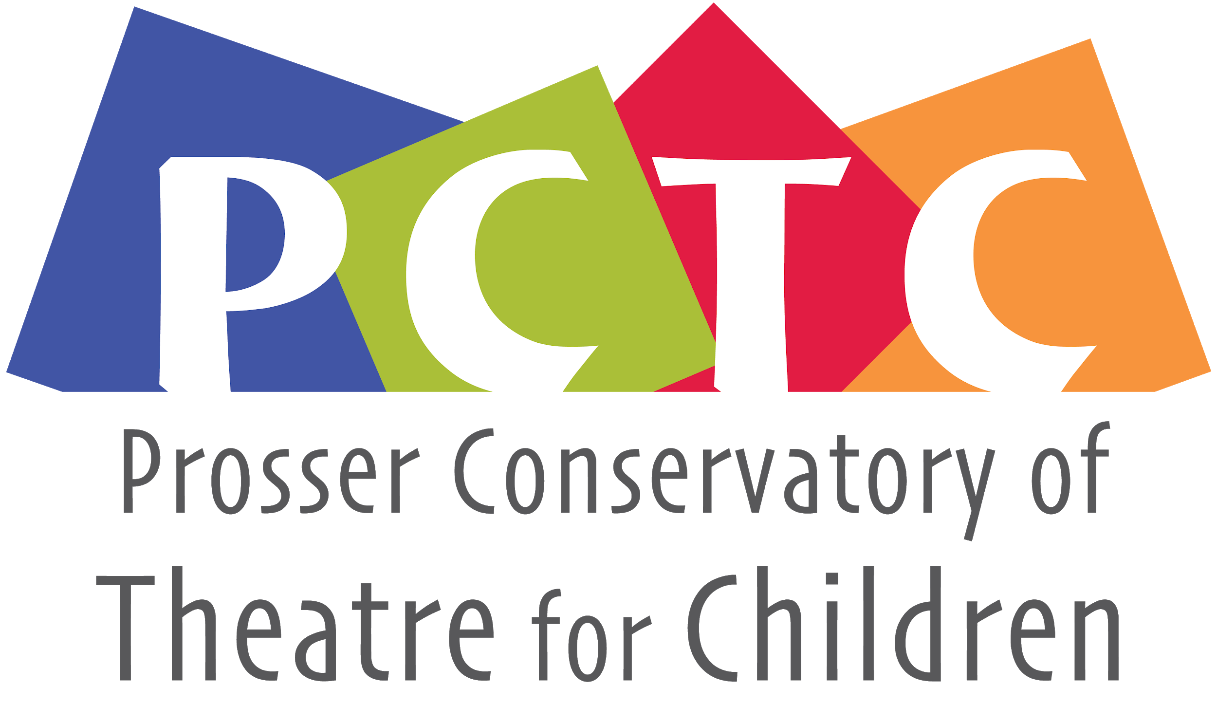
PO Box 1230 , Prosser, WA 99350
prosserconservatory@gmail.com
General Membership Meeting
June 22, 2021 7:00pm • Virtual Zoom Meeting

Board Members
’20-‘22  Monica Ray  Lesa Park  JP Estey  Bethany Riddle | ’19-‘21  Andie Slonecker  Nathan Harris  Ashleigh Thornock  Eva Petroff  Student rep N/A

Call to order:
Present: Lesa, Monica, JP, Bethany, Andie, Nathan
Absent: Ashleigh, Eva

Review and make additions to agenda
Review and approve last meeting’s minutes
Minutes taken by: Andie Slonecker

Officer/Committee Reports
- Business Manager: $16,001.99 today
  - Last Meeting - $13,756.05, insurance hasn’t been paid, registration fees haven’t been added to this number yet.
  - This Meeting -
  - Budget ‘20/’21 – TBD after costumes, production costs, $200, security deposit, programs,
  - Other Items -

Old Business-
- 2021 Conservatory Dates-July 12-24th
- UGN And Grants
  - Call PMH-$600 for shirts, seem to be thrilled to donate (Large)
  - Other Sponsors- Chad Thornock, (Potential) Bunnell, Coldwell Banker , Columbia Title Company, Wit Cellars, Clever Designs (small) and Custom Signs $50 small, $75 large, $150 full page
    - Any update on outreach for these?
- Action items- Andie and Monica will meet with Zoë Wilson to discuss Camp Coordinator duties, PDF’s of parent letters
- Monica will call Lindy and Wit Cellars, Columbia Title Company (Andie) Thornock (Lesa), email the logo if possible
- Monica will contact Valley Publishing to ask about printing

New/Existing Business

- Vax Status-
- Volunteers-
- Camp is 9-3
- Production Meeting with JP, Maddy, Paul, see if Kimberly and LJ, Robin, Leslie, Andie want to join-Dreamscape, cool colors, Human world, warm colors
  - Update- Next production meeting on July 6th
- Attestation Form-have our own on the top of our sign in sheet (one family at a time)
- Printing the Programs—Valley Publishing
- Camp Needs- Costumes, monster hats with a color scheme, Does Alter Ego have anything? Leslie agreed to help. JP thinks minimal costuming 7 monsters to costume.
  - Update
- Update on the Fire behind the princess. It does seem like the walkway from the Greenroom to backstage.
- Reserved the pavilion at Crawford park for post-production-party after strike. No sharing food. Maybe get some pre-packaged cookies, taste of heaven etc.
- Performances on 7PM Friday, 1PM Friday Strike 3-4, Party 5

Future Items
  - Merger Conversation--Table until post-pandemic
  - Next Meeting – 22nd of June 7:30-8:30
- Website Needs:
  - Minutes and Bio –-on hold due to Cyndil’s schedule
  - Previous Sponsors-see above
  - Registration-this is updated
  - Photos – I have access from Jenny Johnson
  - Mission Statement- on hold
  - Group Photo- on hold
  - Minutes for upload- on hold
  - Scholarship Description-

Meeting Adjourned – Meeting adjourned
Next meeting- September 21st 7PM

Camp July 12-24th
Director-JP Estey
Props-Robin Humberstad
Camp Coordinator-Monica and Andie
Education-Paul
Master Classes- Kimberly and LJ
Tech- Maddy Fortney
Costumes-Leslie
After Party at the Park-Lesa

