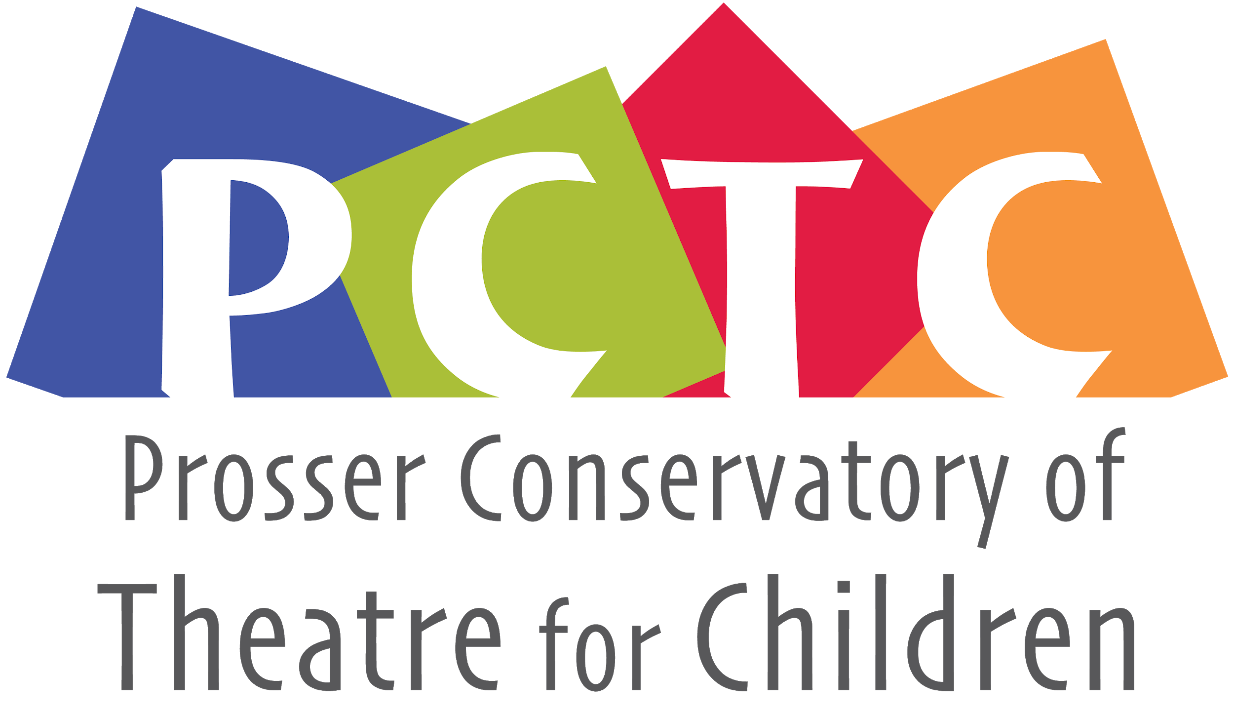
PO Box 1230 , Prosser, WA 99350
prosserconservatory@gmail.com
General Membership Meeting
May 18, 2021 7:00pm • Virtual Zoom Meeting

Board Members
’20-‘22  Monica Ray  Lesa Park  JP Estey  Bethany Riddle | ’19-‘21  Andie Slonecker  Nathan Harris  Ashleigh Thornock  Eva Petroff  Student rep N/A

Call to order: 7:07
Present: Monica, Lesa, JP, Bethany, Andie,
Absent: Nathan, Ashleigh, Eva,

Review and make additions to agenda
Review and approve last meeting’s minutes
Minutes taken by: Andie Slonecker

Officer/Committee Reports
- Business Manager $13,756.05, insurance hasn’t been paid, registration fees haven’t been added to this number yet.
  - Budget ‘20/’21 – TBD after costumes, production costs
  - Other Items -

Old Business-
- 2021 Conservatory Dates-July 12-24th
- Get in touch with Fort Worth Theater and see if they have any new insights. (JP)
- Website Needs:
  - Minutes and Bio –-on hold due to Cyndil’s schedule
  - Previous Sponsors-see above
  - Registration-this is updated
  - Photos – I have access from Jenny Johnson
  - Mission Statement- on hold
  - Group Photo- on hold
  - Minutes for upload- on hold
  - Scholarship Description-
- UGN And Grants
  - Call PMH-$600 for shirts, seem to be thrilled to donate
  - Other Sponsors- Chad Thornock, (Potential) Bunnell, Coldwell Banker, Columbia Title Company, Wit Cellars, Clever Designs and Custom Signs $50 small, $75 large, $150 full page

New Business

- New Lock for Easier Access
- Update on Play- Monster in the Closet, need to buy scripts, director’s book,
- Volunteers-
- Camp Needs- Costumes, monster hats with a color scheme, Does Alter Ego have anything?
- Action items- Andie and Monica will meet with Zoë Wilson to discuss Camp Coordinator duties, PDF’s of parent letters
- Shirts- $15+tax solid or $20+tax acid washed
- Camp is 9-3
- Production Meeting with JP, Maddy, Paul, see if Kimberly and LJ want to join
- No intern this year, because JP is figuring this out as he goes, isn’t ready to share his wisdom yet.
- Health Screening- temperature?, attestation form yes,
- Printing the Programs, Probably do this through the chamber

Future Items
  - Merger Conversation--Table until post-pandemic
  - Next Meeting – 22nd of June 7:30-8:30

Meeting Adjourned – 8:13

Camp July 12-24th
Director-JP Estey
Props-Robin Humberstad
Camp Coordinator-Monica and Andie
Education-Paul
Master Classes- Kimberly and LJ
Tech- Maddy Fortney
Producer-
After Party at the Park-Lesa

