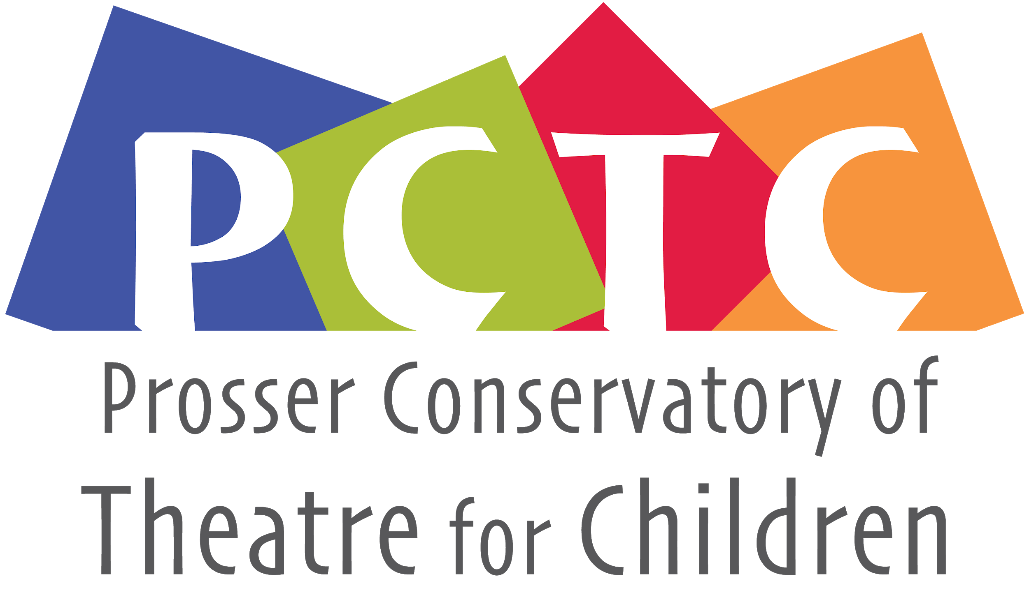
PO Box 1230 , Prosser, WA 99350
prosserconservatory@gmail.com
General Membership Meeting
November 19th, 2020, 6:00pm • Virtual Zoom Meeting

‘18 Now 2020 (up for election today) | ‘19
Maddy Fortney - Not seeking re-election  Monica Ray - Present  Bethany Riddle - Present 7:30  Lesa Park - Present  Student Rep: n/a | Andie Slonecker - Present  Eva Petroff - Absent  Ashleigh Thornock - Present  Nathan Harris - Present 7:44

Call to order - Andie @ 7:05 and Monica Second
Review and make additions to agenda
Review and approve last meeting’s minutes
Minutes taken by: Lesa Park

Officer/Committee Reports
  - Business Manager – Monica Ray
    - Budget ‘20/’21
      - Total Income 3694.66 with a remaining balance 13337.56.
    - Other Costs
      - We went ahead and paid rent.
      - Paid out for keychains
      - website payment
      - Paid for Logo design
      - Master class
      - Tree trimming
    - Total from PCTC Conservatory $700
Website and Logo Conversation
A. New logo with new colors.
B. It was nice to keep it local and it would be nice to work with her
again if needed.
C. We have a new website. It can facilitate paying options and other
things that we didn’t have before
Annual Reports
- Business Manager -Monica Ray - See above
- Report on storage facility- Ashleigh Thornock
  - VTC and PCTC were all there as it is a shared location
  - A dozen people helping with the clean-up
  - We split the cost for the debris removal - $225
  - We can now get in and out but probably won’t need to do that for a while. (Shara has before pictures)
- Report on Conservatory 2020- JP Estey
  - The kids we full of creativity
  - The kids learned script, sounds and recording in a week and were really enthusiastic.
  - The masterclass opportunity was successful and the kids seemed to enjoy it.
  - We collaborated with a theater group in Fort Wayne, IN. We learned a lot about how they did theirs.
- Thank you to volunteers for 2020 -Nathan Harris (Andie)
  - We had many volunteers and this made the program run smooth in classes and background checks.
  - Thank you for all the hard work from the volunteers
- UGN Grant 2021-Monica Ray
  - We originally thought about not applying for 2021
  - They suggested that we apply anyway - We need an amount and reason.
  - Monica suggested $500
  - Maybe something the kids can use throughout the year to brag on their hard work.
- Nominations for board-Andie

New Business
- Election for 2020 board members -Andie Slonecker
‘20 Nominees: JP Estey, Bethany Riddle, Monica Ray, Lesa Park
1. No other nominees
2. Motion to nominate all - Ashleigh Motioned and Andie Second
3. No discussion on this
- 2021 Conservatory Dates
  - We aren’t sure what this is going to look like.
  - Dates blocked:
    - Possibly the 12th-23rd.
- 2021 Options
- UGN Grant 2021 - See Above
- Determine Board Roles
  - President - Social Media - Millesa
  - Vice President - JP
  - Business Manager - Monica
  - Secretary - Andie
- Next Meeting - January
- Misc
  - The Princess Theater is doing a variety show to raise money
  - Video, short, etc…
  - E-mail Bethany with Ideas
  - It cannot be pre-recorded.
  - The highschool is putting on a play “Once Upon a Zoom”
    - Stream through Youtube 10th-12th @ 7pm
    - Tickets are donation only
    - It would be encouraging to comment to the kids when you laughed and enjoyed the play.
- Millesa to get e-mail log in, facebook password, and info for the google drive.

