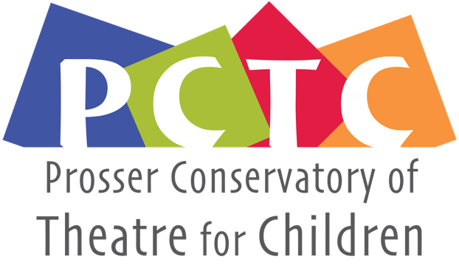
PO Box 1230 , Prosser, WA 99350
prosserconservatory@gmail.com
General Membership Meeting
September 21, 2021 7:45pm • Virtual Zoom Meeting

Board Members
’20-‘22  Monica Ray  Lesa Park  JP Estey  Bethany Riddle | ’19-‘21  Andie Slonecker  Nathan Harris  Ashleigh Thornock  Eva Petroff  Student rep N/A

Call to order:
Present: Monica Ray, Lesa Park, JP Estey, Bethany Riddle, Andie Slonecker, Nathan Harris,
Absent: Ashleigh Thornock,

Review and make additions to agenda
Review and approve last meeting’s minutes
Minutes taken by: Andie Slonecker

Officer/Committee Reports
- Business Manager: $16,027.46
- Still needs to give stipends for the other volunteers- Paul $300, Maddy $300, JP $500 , Nathan $200, Jenny $200
(Monica and Andie as parent volunteers request no stipend)
- Gave $100 each to interns (Rachel Hudack and Elizabeth Humberstad)

Old Business-
- UGN And Grants-Due in December or January look at next month (Monica and Lesa)
- Action items- Stipend for Volunteers-

New/Existing Business
- About five years ago conversation about PCTC and Over the Hill gang joining VTC,
Princess could offer space, insurance, marketing department, PCTC could dissolve board and just run conservatory, offer financial management. At the time that PCTC formed with Kimberly and LJ wanted to pay, VTC didn’t want to pay
- VTC wants to go down to three shows due to and make PCTC the fourth show in their season
- PCTC is a healthy organization right now, maybe more so than VTC
- VTC wants to form a relationship with the students so as they grow from PCTC to HS, and VTC
- PCTC has a solid audience group and would like to encourage those audience
- Monica: How does VTC handle dispersing funds from shows? Supplies etc for our show, Kimberly: Show presents a budget, the board says yes or no, production spends into that, can be paid upfront or present rescripts, Now use a bookkeeper for accounts payable, for example the set designer would pay out of pocket, producer would sign off, then pass on to Accounts Payable. Travis Belisle is currently the VTC business manager.
- Insurance
- Monica: would like a draft from VTC with actual bullet points.
- 2,000 or 2,500 in rent a year.
- Maybe just a MOU that states that we agree to market for each other, we can use each other’s stuff,
- In PCTC and Missoula everyone gets a part, VTC you must try out, and there’s many fewer parts for young people.
- Could we have our joint meeting be our November General Meeting, 3rd Tuesday of November, but need to move to 23rd of November due to
- Lesa: VTC has required a greater parental commitment and hasn’t always been transparent about this (some producers expect an adult per family of kids any time a child is present.
- Future Items

- Website Needs: Lesa will get back in touch with Cyndil and see if she is ready to proceeded.
  - Minutes and Bio
  - Previous Sponsors-see above
  - Registration-this is updated
  - Photos – we have access from Jenny Johnson
  - Mission Statement- on hold
  - Group Photo- on hold
  - Minutes for upload- on hold
  - Scholarship Description-
- Next Meeting
  - Covid protocol for future events
  - Develop discussion points for an agenda for VTC/PCTC meeting
  - October 19th, 7:45 over Zoom
  - November meeting with VTC will be in person

Meeting Adjourned – 8:58

